TASK 8 – Read and print data safely
Use cin to read numeric values and check cin.fail() after input. If the user enters letters where a number is expected, clear the error flag with cin.clear() and discard the invalid line with cin.ignore(numeric_limits<streamsize>::max(), '\\n'). Use iomanip to format rupees and paise.
Safe input and formatted output example
#include <iostream>
#include <limits>
#include <iomanip>
int main() {
int hour;
std::cout << "Enter hour (0-23): ";
if (!(std::cin >> hour)) {
std::cin.clear();
std::cin.ignore(std::numeric_limits<std::streamsize>::max(), '\n');
std::cout << "Invalid input: enter a number.\\n";
return 1;
}
if (hour < 0 || hour > 23) {
std::cout << "Invalid hour\\n";
return 1;
}
long long balancePaise = 10000;
std::cout << "Balance Rs "
<< balancePaise / 100 << '.'
<< std::setw(2) << std::setfill('0')
<< balancePaise % 100 << '\n';
}

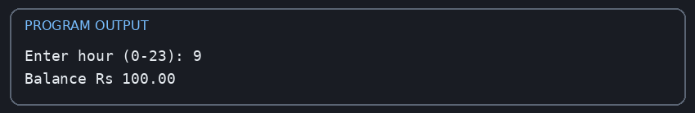
The output panel shows a valid sample run with hour 9. Also test invalid input by typing abc; the program should print the invalid-input message and exit safely.

Alternative concept and complexity
With getline(), the program reads an entire line and converts it using stoi() inside try/catch. Processing a line of length L is O(L), and the input buffer uses O(L) space. cin >> is convenient for simple numeric input; getline plus stoi gives more control over the whole line and exception-based error handling.

